Hi5 — Product Brainstorming & Planning.

1. Core Idea / Product Vision 1
2. Target Users 2
3. Main Application Features 3
4. Application Structure / User Journey 6
5. User Onboarding 8
6. Page-by-Page Brainstorm 9
7. Visual Design 16
8. Random Ideas / Parking Lot 18
9. Monetisation 18

Purpose of this document
This document is our shared space for brainstorming and shaping the Hi5 application before we begin detailed development.
At this stage, ideas do not need to be fully developed or technically validated. Add ideas freely, comment on other suggestions, and expand on anything you think could improve the application.
When adding an idea, add your name/initials next to it so we can discuss it later.
Example:
PJ: Allow users to add private notes to people in their Match Pool.

1. Core Idea / Product Vision

What problem are we trying to solve?
{ Answering these would help adding contents to the pages }
Briefly describe what you think Hi5 should help users achieve.
Questions to think about:
- Why would someone use Hi5 instead of LinkedIn?
- What makes professional matchmaking useful?
- Who is the main target user?
- What type of professional relationships are we helping people create?
- Should Hi5 focus more on collaboration, recruitment, networking, finding co-founders, or all of these?

Ideas
- Simpler UX than LinkedIn encourages more use and hence more matches - KB
- Increasing social connection of solopreneurs - KB
- Helping start-ups move from an idea into production - KB

2. Target Users
{ Answering these would help adding contents to the pages }

Who could use Hi5?
Possible examples:
- Business Development professionals
- Software Developers
- Designers
- Marketing professionals
- Sales professionals
- Operations professionals
- Entrepreneurs
- Startup founders
- Freelancers
- Students / graduates
- Investors
- Product managers

Other user types
- AI Agents if an MCP is provided - KB

What might each user type be looking for?
Example:
Developer
- Someone who can help market a product
- Start-up founder looking for technical support
- Designer to collaborate with
Founder
- Developer
- Sales professional
- Marketing specialist
- Business partner
Add more:

3. Main Application Features
Add any functionality you think Hi5 should have.
Do not worry about which page it belongs on yet.

Profiles
Possible ideas:
- Editable professional profile
- Profile photo
- Name
- Location
- Job title / profession
- Short bio
- Skills
- Experience
- Industries
- Interests
- Current projects
- Portfolio / website links
- LinkedIn / GitHub links
Additional ideas:
- Feature to block matches
- Spam protection

Matching
Possible ideas:
- Swipe left / right
- Like another profile
- Mutual likes create a match
- Filters
- Skill-based matching
- Industry filters
- Location filters
- Looking-for filters
- Match percentage
- Recommended profiles
Additional ideas:

Messaging
Possible ideas:
- Chat after matching
- Conversation list
- Read/unread messages
- Message notifications
- Profile preview from conversation
- Remove / archive conversation
Additional ideas:

Match Pool
A place where users can organise and manage their existing matches.
Possible ideas:
- View all matches
- Favourite important matches
- Create a priority hierarchy
- Add private personal notes about a match
- Categorise matches
- Archive matches
- Search matches
- Sort matches
Possible categories:
- High Priority
- Potential Collaboration
- Interesting Contact
- Contact Later
- Active Discussion
- Archived
Additional ideas:

Notifications
Possible notifications:
- New match
- New message
- Someone liked you
- Profile suggestion
- Match activity
- Connection reminder
Additional ideas:

Other Features
Add anything that does not fit the categories above.

4. Application Structure / User Journey
Here we decide what pages/screens the application should contain and how users move between them.

Current Initial Structure

1. Landing Page
↓

2. Login / Register
↓

3. Home / Profile - Main authenticated application
Editable personal information and professional profile.
Possible navigation:
Home / Profile
Match Search
Match Pool
Messages
Notifications
Settings

Proposed Pages

Public pages
- Landing Page
- Login
- Register
- Forgot Password

Main application
- Home / Profile
- Match Search
- Match Pool
- Messages
- Individual Chat
- Notifications
- Settings

Possible additional pages

5. User Onboarding
What happens when someone creates an account?
Possible flow:
Register
↓
Basic personal information
↓
Professional information
↓
Skills
↓
What are you looking for?
↓
Industries / interests
↓
Location preferences
↓
Profile complete
↓
Start matching
Questions:
- How much information should we require?
- What information should be optional?
- Should users select what they are looking for?
- Should users select multiple goals?
Possible goals:
- Find collaborators
- Find developers
- Find business partners
- Find clients
- Find freelance work
- Find co-founders
- Find mentors
- Find marketing help
- Find sales help
- Grow professional network
Ideas:

6. Page-by-Page Brainstorm
For each page, think about:
What should the page achieve?
What information should appear?
What can the user do?
Buttons, cards, swiping, animations, filters, etc.
Images, illustrations, icons, layouts.
Add a screenshot, drawing, wireframe, Figma image, or simple diagram.

Landing Page

Purpose
Explain Hi5 quickly and encourage users to join within 10 - 20 seconds.

Text content
Possible:
- Main headline
- “Start using now” button
- Short description
- Why they need it?
- Why us?
- How Hi5 works
- Benefits
Ideas:
- Kradoz Description as a reference https://play.google.com/store/apps/details?id=com.kradoz.app&pcampaignid=web_share

Rough layout / references
Add images, links, sketches or screenshots here. Maybe screenshots or links of landing pages from other websites that we can “borrow”.

Login Page

Content
- Email
- Password
- Login button
- Forgot password
- Register link
Additional ideas:

Register Page

Content
- Name
- Email
- Password
- Confirm password
Additional ideas:

Home / Profile Page
Main personal dashboard/profile.

Possible content
- Profile photo
- Name
- Professional title
- Location
- Bio
- Skills
- Experience
- Current goals
- What I am looking for
- Industries
- Links
- Edit Profile

Dashboard elements
Possible:
- Number of matches
- New messages
- Profile completeness
- Recent matches
Additional ideas:

Match Search
Core discovery/swiping experience.

Profile card could contain
- Photo
- Name
- Role
- Location
- Skills
- Short bio
- Looking for
- Industry
- Shared interests
- Match compatibility

Actions
- Swipe left
- Swipe right
- Open full profile

Filters
- Profession
- Skills
- Industry
- Location
- Collaboration type
- Experience
Additional ideas:

Match Pool
Purpose:
Organise people the user has matched with.

Possible features
- All Matches
- Favourites
- Priority ranking
- Categories
- Personal notes
- Search
- Filters
- Sort
- Archive

Match card
Possible information:
- Name
- Role
- Priority
- Notes
- Tags
- Message button
Additional ideas:

Messages

Main messaging page
- Conversation list
- Search conversations
- Unread indicators
- Latest message preview
- Time of latest message

Chat page
- Messages
- Profile preview
- Message input
Additional ideas:

Hi5
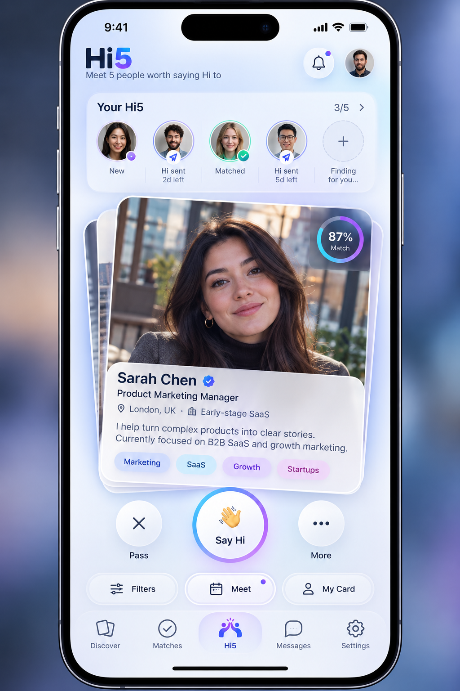
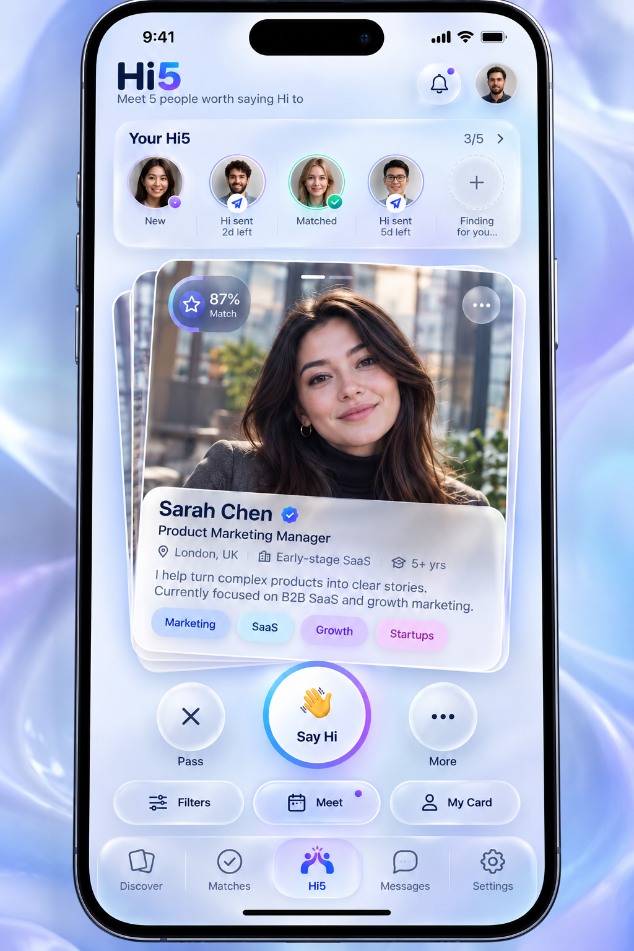

Notifications
Possible notifications:
- New Match
- New Message
- New Like
- Recommendation
- Profile activity
Ideas:
- Hi 5 connection about to expire (after 3 days) - Hatim
- How about “Expires in 5 days?” So it aligns with the name of Hi 5 – “meet 5 people within 5 days!” - KB

Settings
Possible:
- Account
- Email
- Password
- Notification preferences
- Matching preferences
- Privacy
- Delete account
- Logout
Ideas:

7. Visual Design
Add ideas, screenshots, links and references freely.

Overall Style
What should Hi5 feel like?
Possible descriptions:
- Modern
- Professional
- Friendly
- Startup-style
- Minimal
- Premium
- Social
- Playful but professional
Ideas:

Colour Palette
Possible colours:
Primary:
Secondary:
Accent:
Background:
Text:
Add screenshots/palettes here.


Typography
Possible fonts:
- Set of 3-4 professional fonts

Consider:
- Heading font
- Body font
- Buttons
- Profile cards

8. Random Ideas / Parking Lot
If you have an idea but do not know where it belongs, put it here.
We can organise these later.
- New user can search with a bare amount of profile info input, will encourage usage. They only have to fill out their profile in full when they want to connect with a match. - KB

9. Monetisation
How to make a profit
- Free to use in the first month to build network effect and habit. - KB
- Fee structure
- Bronze - 1 search a week $5
- Silver – 3 searches a week - $7
- Gold – Unlimited - $10

